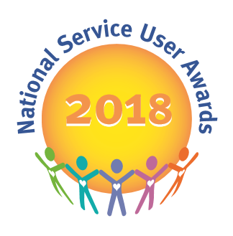
National Service User Awards
Nomination Form
Please return this completed form to louisebannister@cygnethealth.co.uk
The deadline for entries is: Friday 8th December 2017

PLEASE DO NOT include any service user identifiable information on this form as the email address is not secure and nominations need to be anonymous for the shortlisting process.

The judging day will take place in early January 2018 - successfully shortlisted finalists will be notified by the end of January and invited to attend the ceremony in April 2018.

Ward/ Service Name:
Hospital/Unit:
Organisation/Company/Trust Name:
Submitted by | Name:  Role:

Nomination category – please tick below as appropriate for your entry:

- Community, Social or Vocational Initiative
- Recovery and the Arts
- Breaking Down Barriers and Reducing Stigma
- Health and Well-being Initiative
- Outstanding service user achievement award

Name/ Title of Initiative: (maximum 10 words)
Your reference:
Your reference should not include any service user identifiable information. This reference is to help you to identify the nomination if shortlisted, where you / your service have submitted multiple entries.

Person to be contacted in the event of a successful nomination:
Phone number:
Email Address:

Brief summary of initiative in no more than 50 words
(if successful this will be printed in the Awards programme, so 50 words is the strict limit)
Full overview of project (no word limit)
Please consider the following in your response:
- How involved service users have been in the project
- What impact the project has had on service users and the service as a whole
- The sustainability of the project
- How innovative it is
- How easily it could be replicated/rolled out in other services
Comments from service users involved in the project or any other additional information:
If you wish to include any supporting information / evidence please include as an email attachment, or send via post, clearly labelled with your entry name to:
NSUA, c/o Louise Bannister, Cygnet Hospital Derby, 100 City Gate, London Road, Derby, DE24 8WZ

